Tosca Servers HP-UX reboot SOP
Do the prechecks before shutdown/reboot
bdf command to check the disk space
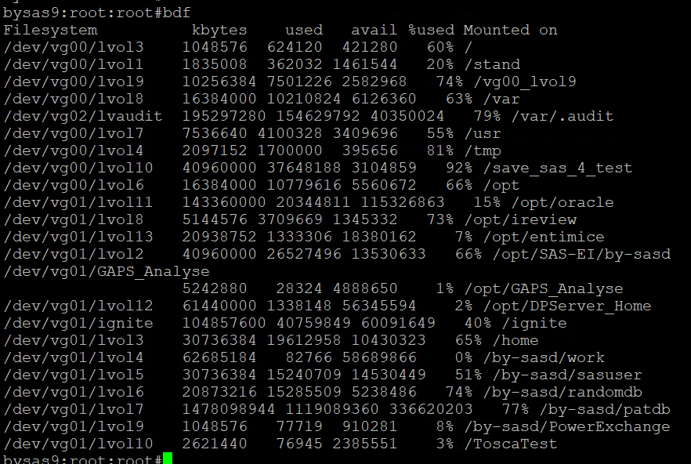
netstat -in ( command to check the IP address)
netstat -rn (command to check the gateway)
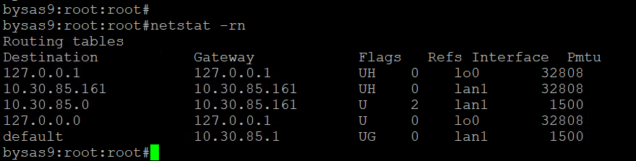
uptime
date;
uname -r
uname -a
cat /etc/fstab
bdf
netstat -an
netstat -nr
cat /etc/fstab |grep -i nfs |wc -l
cat /etc/fstab |wc -l
bdf |wc -l
model
machinfo
cat /etc/resolv.conf
ps -ef | grep -i pmon
bdf | grep -i sap
ps -ef |grep mysql
ps -ef |grep post
ps -ef |grep mongo

to take the crontab backup for each user
for user in $(ls /var/spool/cron/crontabs); do
crontab -l "$user" > /tmp/"$user"_crontab.bak
done
Check the last OS backup status on the server ( We have check the backup from server and ignite backup server)
On the bysas9 test server check the crontab
cat /usr/bayer/sbin/ignite_backup_1.3.sh
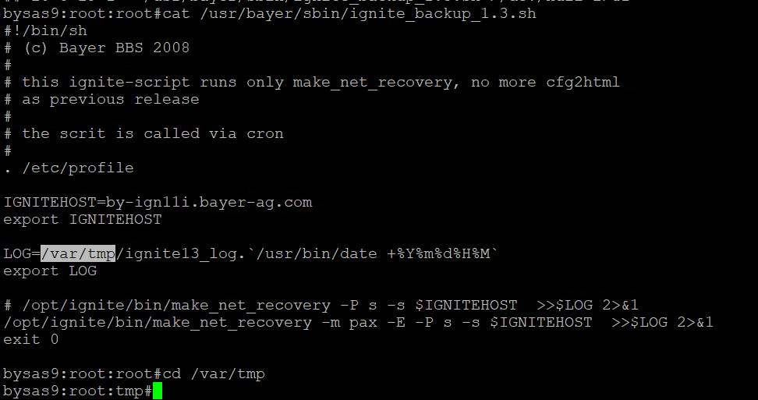
cd /var/tmp
ls -lrt ignite13_log.*
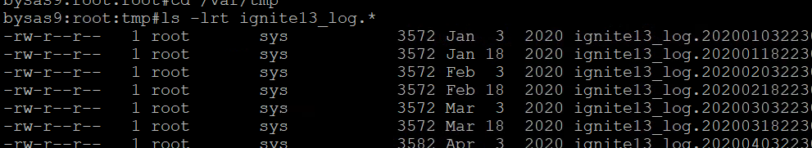
check the latest log file
tail -100f ignite13_log.202511182230
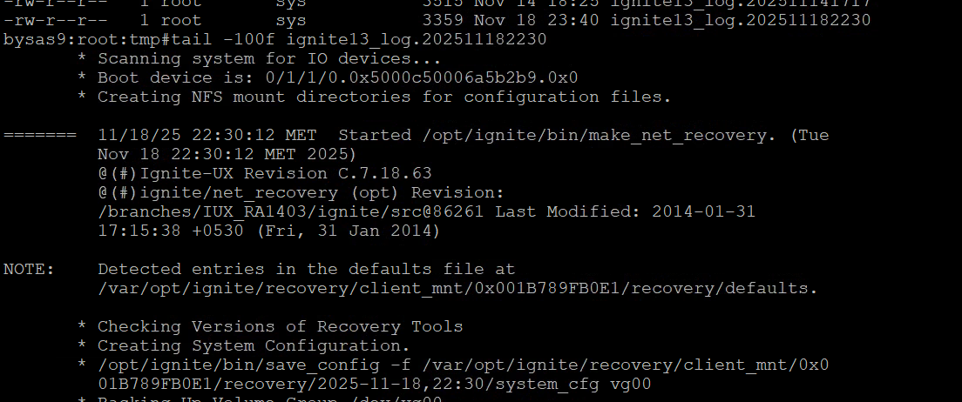
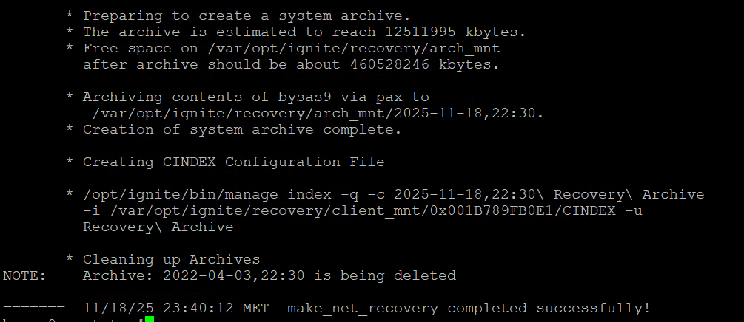
You will see the last backup status with date and time.
Similarly on the ignite server by-ign11i you can check the last backup backup status
login to by-ign11i
cd /var/opt/ignite/clients/bysas9/recovery/latest
tail -f recovery.log
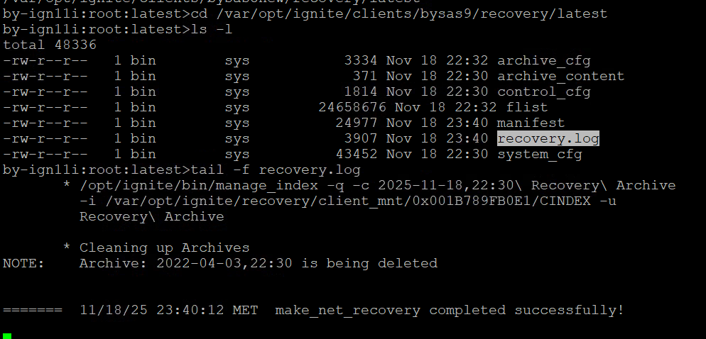
The backup status can be checked from the recovery.log for client bysas9.
similarly you can check for other clients as well going into the respective folder and change the client name /var/opt/ignite/clients/<client_name>/recovery/latest
check the archive logs are created for each client by changing the client name and you can see the when the last archive was created
cd /var/opt/ignite/recovery/archives/bysas9
ls -lrt
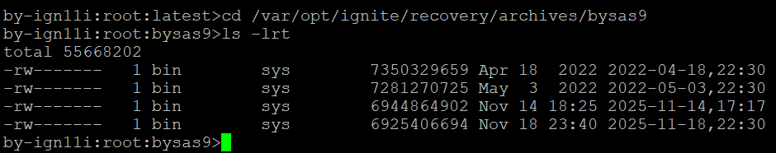
Note: donot open the files under the archives as these files are used for recovery of OS
For the Data backup needs to be with the networker backup team for the latest data backup
Before shutdown or reboot the server we need to check the cluster status For Halting the cluster and stopping the package
cmviewcl (command to check the status of the cluster)
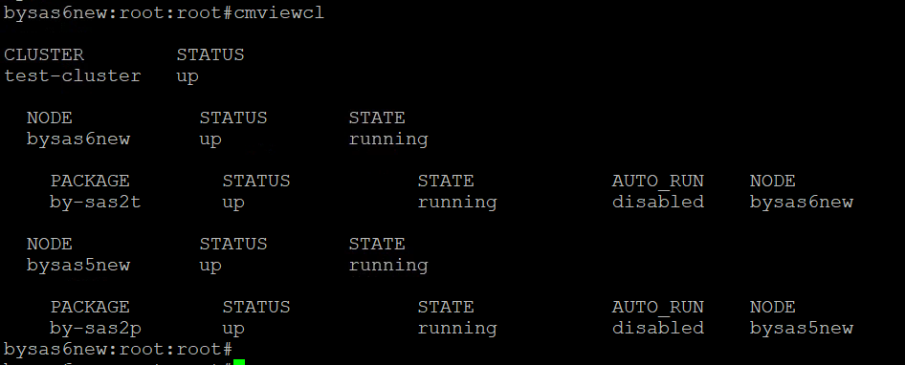

cmviewcl -v (command to check the cluster name and Quorum status and node switching parameter)
In the below output cluster name is test-cluster and Quorum status is up
and node switching parameter is bysas5new where currently production is running.
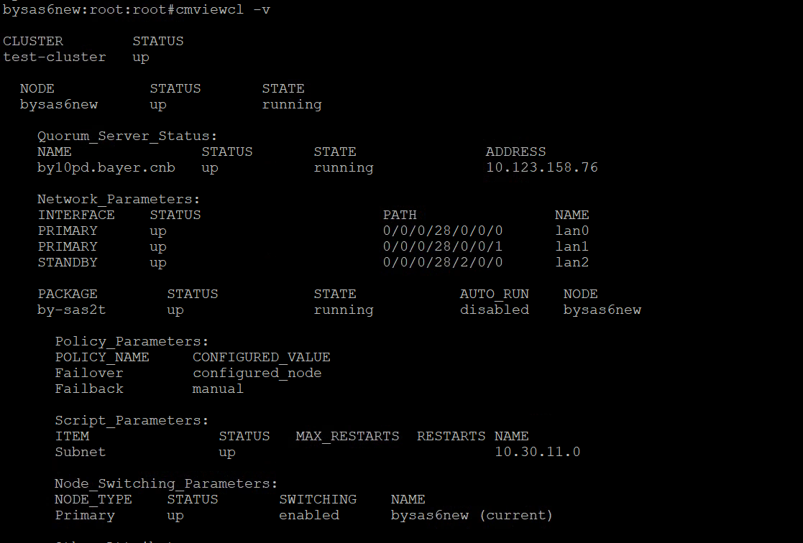
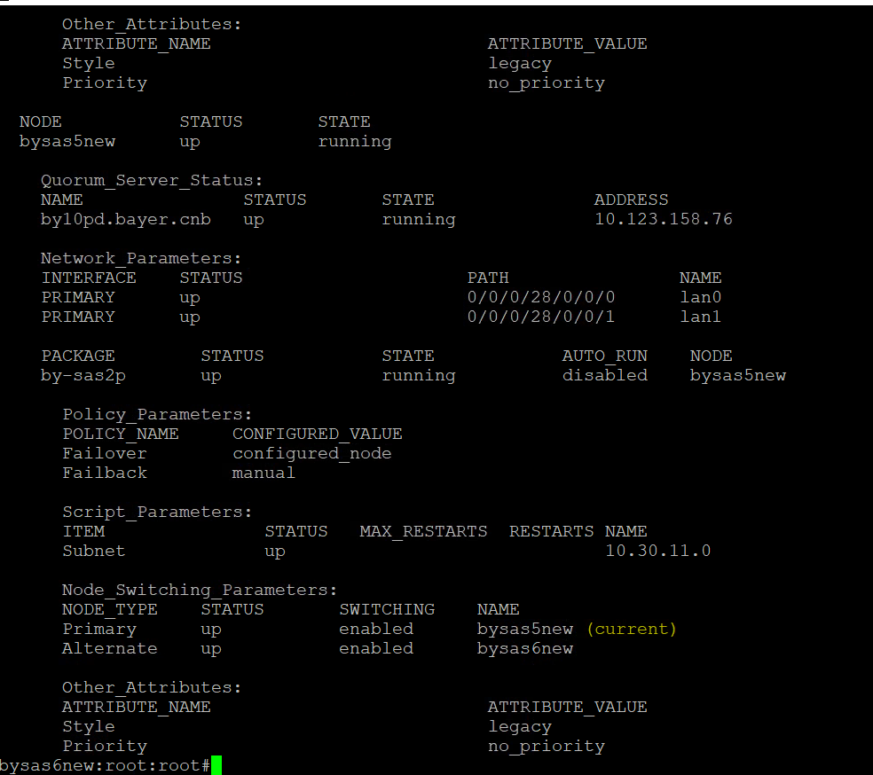
You need to login to individual server and stop the package for the respective node
First check the package name for respective node.
For example in the above output the I had login to bysas6new server the cluster package name is by-sas2t
For stopping the cluster you must stop the cluster package first.
cmhaltpkg packagename (command to halt the package)
example: cmhaltpkg by-sas2t
run cmviewcl to check the cluster package status
you will receive a successful message after stopping the package
If any error check the logs
cd /etc/cmcluster/<package-name>
cd /etc/cmcluster/by-sas2t
tail -100f by-sas2t.cntl.log
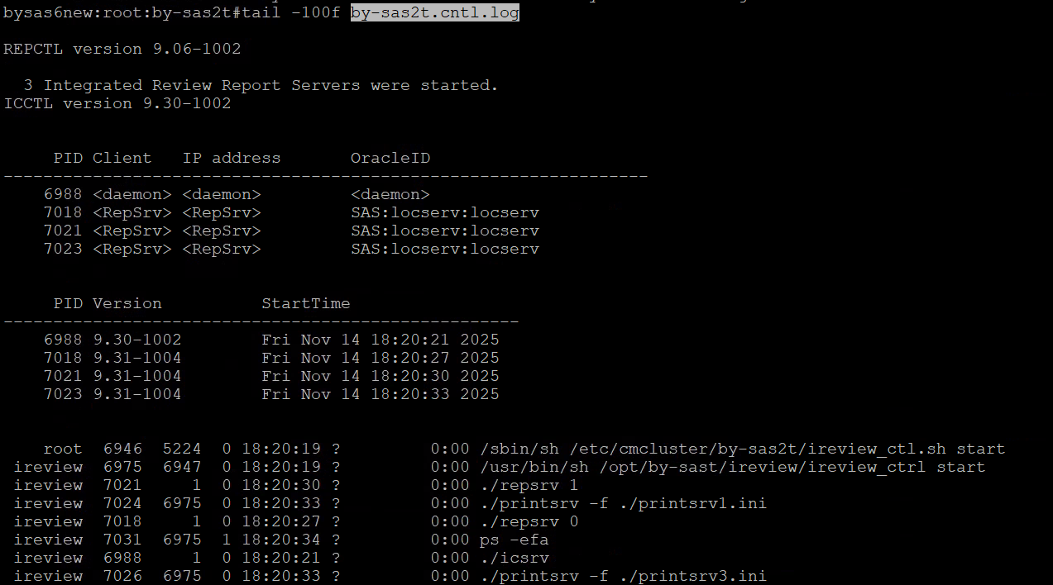
Second step is to halt the node
cmhaltnode <node_name>
cmhaltnode bysas6new
run cmviewcl to check the node status
after successfully halting the node we need to shutdown the server

shutdown -ry 0/now (command to reboot the server)
shutdown -h now ( command to shutdown the server)
Login to ILO console through jump server sclad4 and from there connect to
by-apex jump server check the below screenshot I had logged into bysas9 server ILO
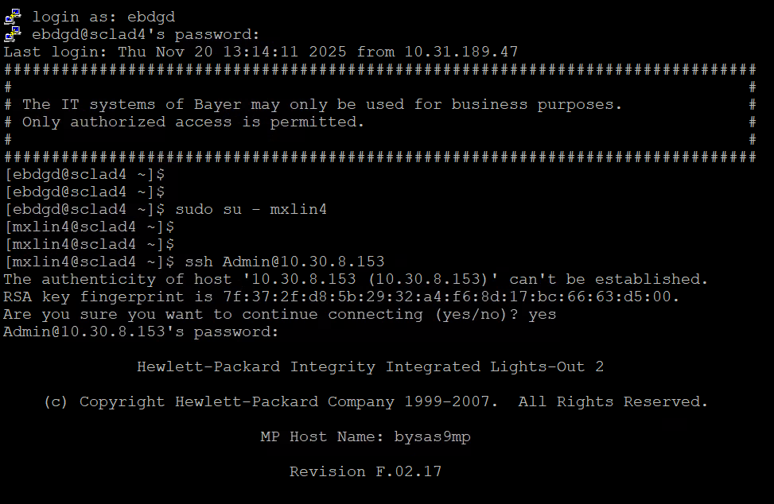
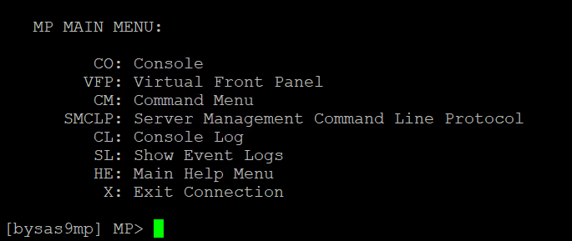
after connecting to ILO console via putty we will to run CO command to goto CONSOLE where we can see all the boot messages.
We can login the server via console with the os creds
Console Login: mxlin4
password: ******
CO
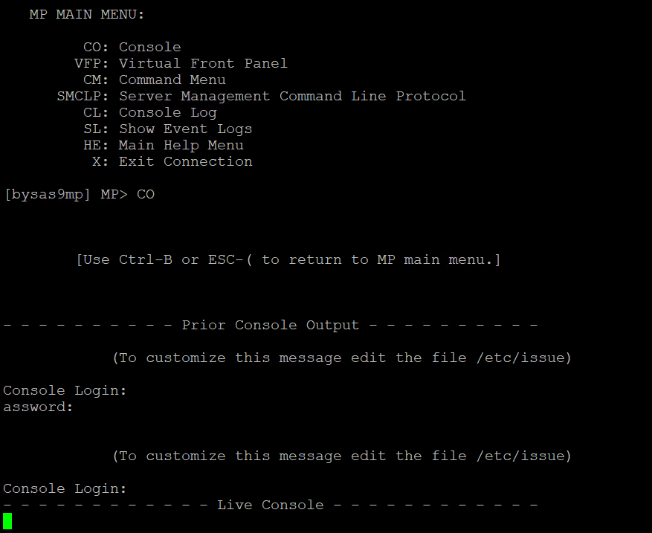
Ctrl+B to come out of Console
to come out of the ILO
enter X

after reboot we need to bring the cluster services up

cmviewcl (first run this command to check the package and node is up)

if the package or node is not up we need to bring the node up first.
cmrunnode -v <node_name>
cmrunnode -v bysas6new
run cmviewcl to check the node status
after successfully bringing the node up we need to start the package
cmrunpkg <package_name>
cmrunpkg by-sas2t
run cmviewcl to check the package status

Currently the Autofailover is in disabled states for both the nodes (bysas5new and bysas6new)
#cmmodpkg -e by-sas2p (to enable the Auto failover)

cmmodpkg -d by-sas2p (to disable the Auto failover)
Postchecks after reboot
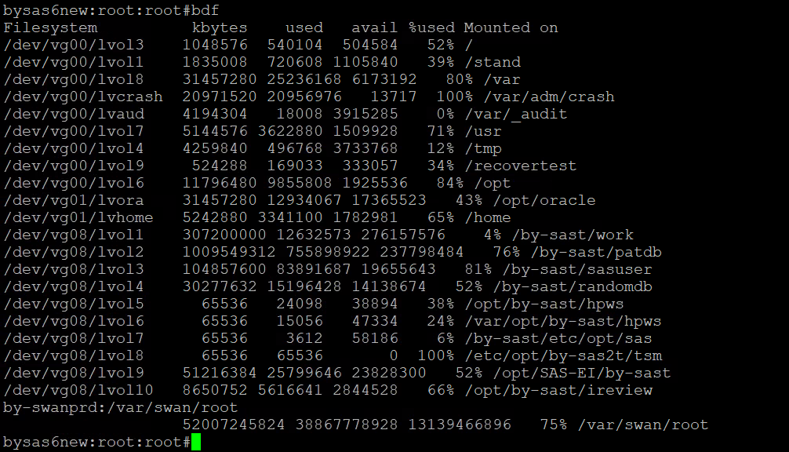
we need to verify the mount points which are mounted as you can see the vg08 volume group is in cluster.
bdf /var/swan/root ( we need to verify this nfs mount point if it is mounted or not)

The nfs share from by-sas2p/bysas5new are exported to by-swanprd

cat /etc/dfs/dfstab (nfs share configuration file on bysas5new) (nfs export)
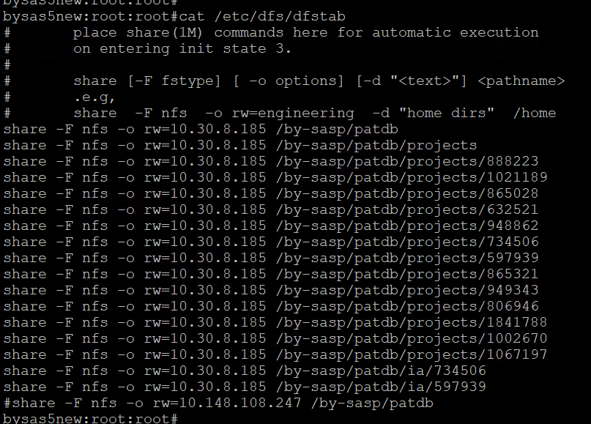
on bysas5new if you want to stop exporting the nfs share we can run the below command
be precautious before doing unshareall as it will stop exporting the nfs share.
unshareall (command to stop exporting the nfs share)
shareall (command to export the nfs share)

On the nfs client

we can verify after login on the server by-swanprd
by-swanprd#
df -PTh|grep -i nfs ( this will show all the nfs mount points) we need to verify them
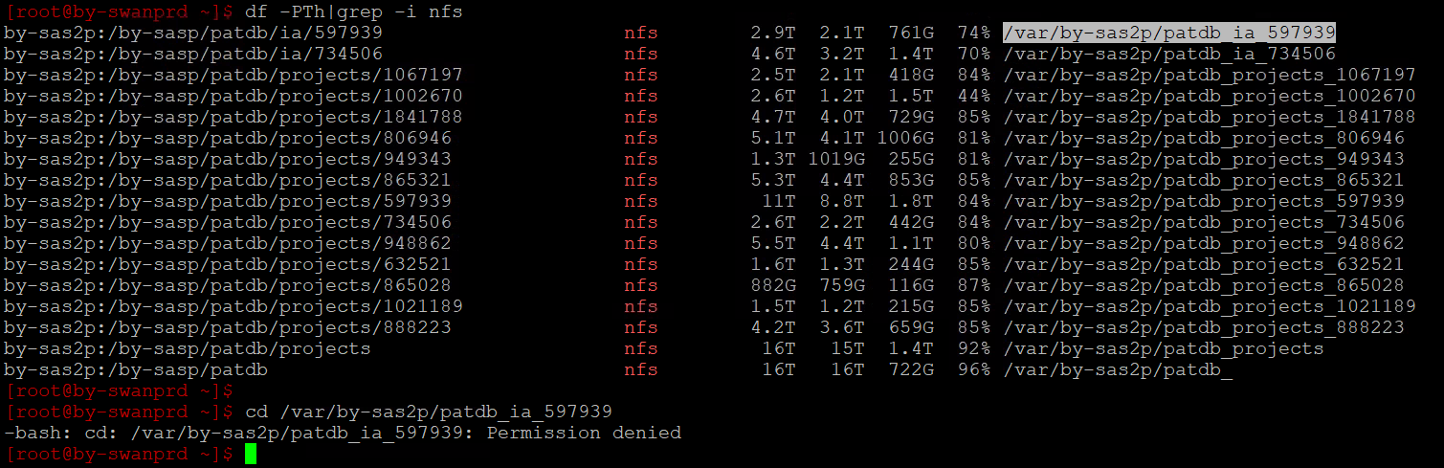
check the fstab entries
cat /etc/fstab|grep -i nfs
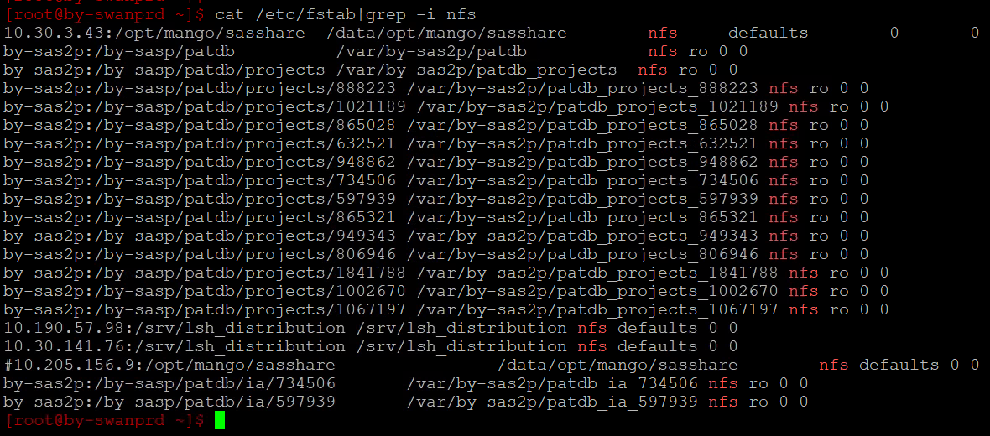
if nfs mount points are missing we need to manually mount them in this order only
mount -t nfs -o ro,vers=3 by-sas2p:/by-sasp/patdb/projects/888223 /var/by-sas2p/patdb_projects_888223
mount -t nfs -o ro,vers=3 by-sas2p:/by-sasp/patdb/projects/1021189 /var/by-sas2p/patdb_projects_1021189
mount -t nfs -o ro,vers=3 by-sas2p:/by-sasp/patdb/projects/865028 /var/by-sas2p/patdb_projects_865028
mount -t nfs -o ro,vers=3 by-sas2p:/by-sasp/patdb/projects/632521 /var/by-sas2p/patdb_projects_632521
mount -t nfs -o ro,vers=3 by-sas2p:/by-sasp/patdb/projects/948862 /var/by-sas2p/patdb_projects_948862
mount -t nfs -o ro,vers=3 by-sas2p:/by-sasp/patdb/projects/734506 /var/by-sas2p/patdb_projects_734506
mount -t nfs -o ro,vers=3 by-sas2p:/by-sasp/patdb/projects/597939 /var/by-sas2p/patdb_projects_597939
mount -t nfs -o ro,vers=3 by-sas2p:/by-sasp/patdb/projects/865321 /var/by-sas2p/patdb_projects_865321
mount -t nfs -o ro,vers=3 by-sas2p:/by-sasp/patdb/projects/949343 /var/by-sas2p/patdb_projects_949343
mount -t nfs -o ro,vers=3 by-sas2p:/by-sasp/patdb/projects/806946 /var/by-sas2p/patdb_projects_806946
mount -t nfs -o ro,vers=3 by-sas2p:/by-sasp/patdb/projects/1841788 /var/by-sas2p/patdb_projects_1841788
mount -t nfs -o ro,vers=3 by-sas2p:/by-sasp/patdb/projects/1002670 /var/by-sas2p/patdb_projects_1002670
mount -t nfs -o ro,vers=3 by-sas2p:/by-sasp/patdb/projects/1067197 /var/by-sas2p/patdb_projects_1067197
mount -t nfs -o ro,vers=3 by-sas2p:/by-sasp/patdb/ia/734506 /var/by-sas2p/patdb_ia_734506
mount -t nfs -o ro,vers=3 by-sas2p:/by-sasp/patdb/ia/597939 /var/by-sas2p/patdb_ia_597939
mount -t nfs -o ro,vers=3 by-sas2p:/by-sasp/patdb/projects /var/by-sas2p/patdb_projects
mount -t nfs -o ro,vers=3 by-sas2p:/by-sasp/patdb /var/by-sas2p/patdb_
after mounting the nfs share verify them by running the below command
df -PTh|grep -i nfs
As ACL permissions are applied to patdb folder we will get the permission denied if we run change directory command as below
[root@by-swanprd ~]$ cd /var/by-sas2p/patdb_ia_597939
-bash: cd: /var/by-sas2p/patdb_ia_597939: Permission denied

